Summary of the study results

* The analysis reviewed four main regimes: Capomulin, Ramicane, Infubinol, and Ceftamin.
* 230 Mice underwent treatment with Capomulin, 228 with Ramicane, 178 with Infubinol, and 178 with Ceftamin.

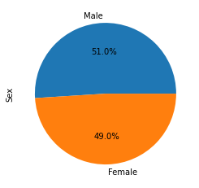

* The proportion of mice tested was almost the same between genders (51% Male and 49% Female). The result shows a difference of 2% between Male and Female.

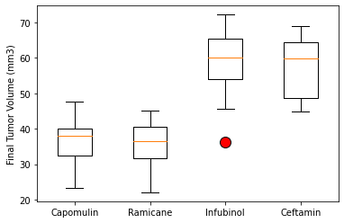

* The Drug Regimes with the lowest Tumour Volumes over time were Capomulin and Ramicane, with final mean tumour volumes of 36.667 mm3 and 36.191 mm3, respectively. The lowest performer was Infubinol, with last mean tumour volumes of 57.754 mm3.

* The volume decreased over time in a mouse undergoing Capomulin treatment.

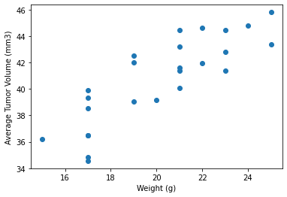

* There is a strong correlation between the Average Tumour Volume and the Mice’s Weight. The correlation between mouse weight and the average tumour volume is 0.84